Screen Layout

The purposes and goals of the screen layout are to…
- Clearly Indicate when the player is currently engaged in a mission
- Clearly indicate what type of Primary Mission Objective the player is currently engaged in
- Clearly indicate the goals of the objective
- Represent specific Mission collectables as icons on the HUD
- Represent the current Mission objective status (number of icons collected)
- Indicate the current Mission Objective criteria (time, race position)
- Indicate the location and proximity of Mission Objectives (characters, landmarks, objects)
- Represent specific Level collectables or objective as an icons on the HUD (characters, landmarks, objects)
- Represent the current Level objective status (number of icons collected)

Goals of the Screen Layout are to…
- Disappear when not required (typical to next gen games)
- Be clear
- Be intuitive
- Icon driven vs. Text driven (to avoid localization)
- Be helpful
- Content driven
- Visual and Auditory Energy
- Be consistent in location and icons
- Be repetitive
- Have a minimum number of thing for the player to interpret
- Incorporate the Tutorial radio

Screen Layout Proposal

The proposal is to divide the screen into five quadrants where information consistently appears only when required. These quadrants are…
- Current Mission Objectives Criteria (Upper Left Hand)
- Mission Objective Messages (Bottom Left Hand)
- Level Progress Information (Upper Right Hand)
- HUD Navigation (Bottom Right)
- In-Game Messages (Center)

Current Mission Objectives Criteria

Current Mission Objectives include…
- Timer
- Race Position
- Collected / Remaining collectables
- Amount of damage inflicted
- Proximity

Current Mission Objectives MESSAGE

When a player begins a mission the current mission objectives quadrant on the screen will be populated with information regarding the mission objective.

Current Mission Objectives include….
- Current Mission Objective Icon (characters, landmarks, objects)
- Current Mission Objective Text box

When a mission objective is given the icon and message will appear for X seconds. After X seconds the icon will translate to the upper left hand corner and the text message will disappear.

Mission Objectives Icons

When a player is engaged in a Mission the current mission objectives quadrant on the screen will be populated with information regarding the mission objective. This will occur with a simple and consistent set of objectives icons that when combined illustrate the current objective type, representation of the objective and the status of the objective.

Objective Type icons include…
- Racing
- Chasing
- Avoiding
- Collecting
- Talk to
- Go to
- Inflicting Damage
- Tutorial Radio
- Landmark (specific)
- Character (specific)
- Collectable objects (specific)

Mission Objectives Text

When the player begins a mission the current mission objective is given with an icon and a text message. Mission Objectives text should be short and concise.

Level Progression Information

In the top right hand corner Level Progression information will appear when objects are collected. Level progression collectables include…

- Cola Coins
- Collector Cards
- Level Races (completed/ remaining)


Complete information on Level Progression can be found in the Pause Menu HUD.

In-Car navigation

When the player engages Mission Objectives that require navigation a HUD radar will appear in the bottom right hand corner. In addition, In-game icons will appear at key intersections to assist in Navigation. (see Navigation doc.)

HUD Radar

When required the HUD radar appears in the bottom right hand corner of the screen. The HUD radar disappears when not required, or when the player exist the vehicle.

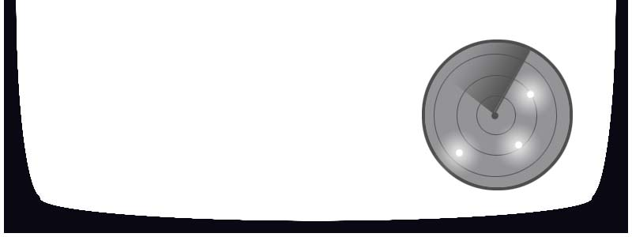

In-Game Updates

In the middle of the screen in game updates will appear briefly to instruct or assist the player. In-Game Updates include…

- Mission Objectives
- Mission Complete / Failure Message
- Race Countdowns (3, 2, 1)
- Stage Complete / Failure Message
- Item recently collected appear then move to Current Mission Objectives or Level Progression

Typical Screen Layout

